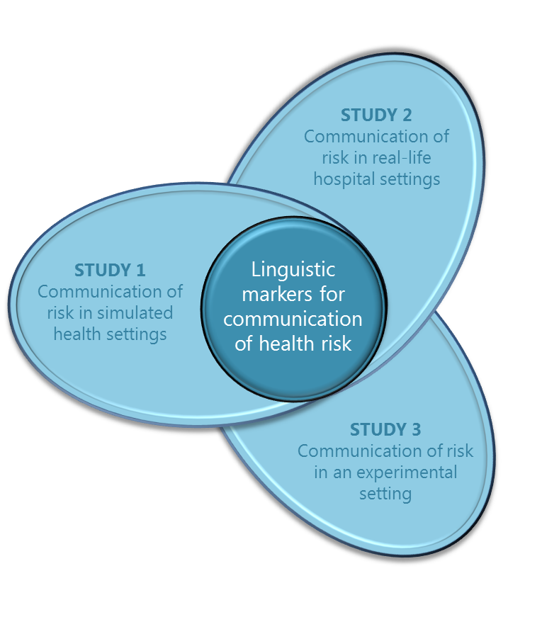

***THE INVESTIGATORS***

***Chief Investigator***

*A/Prof Renata Meuter*

*Queensland University of Technology*

***Chief Investigator***

*Emeritus Professor Cindy Gallois*

*University of Queensland*

***Partner Investigator***

*Professor Norman Segalowitz*

*Concordia University, Montreal*

***Partner Investigator***

*Dr Andrew Ryder*

*Concordia University, Montreal*



**Study 3 – Using healthcare relevant language expressions**

This laboratory based study investigates the way in which specific linguistic expressions may be processed differently by native versus non-native speakers. In particular, the study focuses on the ways in which people understand the meaning of *epistemic adverbs* such as “probably”, “possibly”, or “definitely” to convey risk in medical contexts.

**Progress update:** The abstract of this study has been accepted for presentation at theAmerican Association of Applied Linguistics conference in March 2015. The title of the poster is: **Expressing Doubt and Certainty: Differences and Similarities in Processing Epistemic Adverbs by Monolinguals and Bilinguals in Canada and Australia.**

**Study 2 – Communication of risk in the hospital setting**

This study investigates communication of risk in real, hospital-based patient-clinician interactions.

**Progress update:** Since starting our data collection in October, we have focused on data collection at Logan Hospital. We have received fantastic support from the staff and patients at Logan, and so far have recorded over 20 patient-clinician interactions!

**Study 1 – Role-play simulation of communication effectiveness**

This study makes recordings of conversations between trainee health practitioners when they role-play a patient–clinician scenario.

**Progress update:** 230 QUT health faculty undergraduate students participated in the study. All students filled out a questionnaire on how effective they believed their communication was, and a subset of interactions was recorded for further analysis. The questionnaire data have been analysed and a manuscript is being prepared for publication.

# The Health Communication Project

This Australian Research Council funded international collaboration between Australian and Canadian researchers is designed to understand communication of health risk when a health practitioner and patient do not share the same first language. It comprises three independent studies:

February 2015

Health Communication Project

Newsletter

volume 2 issue 1



# Spotlight on our associate investigator Dr Bernadette Watson

Bernadette is a senior lecturer in psychology at The University of Queensland and also researches effective communication in a health context. She does this by examining conversations between health professionals from different disciplines, and between health professionals and their patients.



Bernadette’s research has consistently shown that patients are happier when health professionals treat their patients as individuals, show empathy, and provide reassurance. Her research has also shown that it is important for patients to feel they can actively engage in the medical consultation and are able to ask questions and clarify understanding. Effective and satisfying interactions between patients and health professionals are important factors in good patient outcome and treatment adherence.

We are fortunate to have Bernadette’s expertise on the project for helping to interpret the outcomes from the simulated role-play study, as well as providing her experience and insights into communication between patients and health professionals for the hospital based study.

# Vacation Research Experience Scheme



We very much enjoyed having Jenny Li on the team in Brisbane during the summer break. Jenny was awarded a highly competitive scholarship from QUT: the Vacation Research Experience Scheme (VRES). The VRES enables high-achieving undergraduate students to gain ‘hands-on’ research experience by working on a project under the guidance of experienced supervisors over the summer vacation period. QUT students in their second, third or final year of undergraduate study with a course GPA of 5 or above are eligible to apply.

Jenny learnt a lot of new skills during her time on the project, which culminated in the development of a new health communication questionnaire, designed to investigate the effect that language, job status and ethnicity has on the amount of trust we place in a health practitioner. The survey will be run during the first semester of 2015, using QUT’s own online survey software “Key Survey”.

***THE RESEARCH TEAM***

***Research Associate:*** *Dr Julia Hocking*

*Queensland University of Technology*

***Associate Investigator:*** *Dr Bernadette Watson*

*University of Queensland*

***Research Assistant / PhD Student:*** *Ms Yue Zhao*

*Concordia University*

***Research Assistant / PhD student:*** *Mr Ivan Chang*

*Queensland University of Technology*

***Research Assistant:*** *Ms Cathy Cleary*

*Queensland University of Technology*

***Research Assistant:*** *Mr Vincent Tam*

*Queensland University of Technology*

# Data collection at Logan Hospital

So far we have recorded 20 conversations at Logan Hospital, from antenatal, surgical, and allied health departments. Antenatal booking-in and review sessions have provided us with the longest conversations at > 30 min. In the surgical department, pre-surgery sessions have been our main focus and have enabled us to record a range of practitioners, including an anaesthetist, a pharmacist and nurses. In allied health we have so far focused on dieticians, but would love to record from a range of professions.

# Participate in the research



Are you a health practitioner at one of our partner hospitals? Would you like to participate in the research, or find out more information?

Email: [healthcommunication@qut.edu.au](mailto:healthcommunication@qut.edu.au), phone us at our Brisbane office on 07 3138 4610 or send us a text 0414 692 496.

Alternatively, just scan the barcode to receive our contact details direct to your smartphone